# CALVARY SCHOLARSHIP BOARD_HOMEPAGE_TOMIWA OLANIYAN-RMP 1.1.0

|  |  |
| --- | --- |
| **Target release** | Version 1.1 |
| **Epic** | Calvary Scholarship Board Homepage |
| **Document status** | DRAFT |
| **Project Sponsor** | Sean Audley |
| **Document owner** | Tomi Olaniyan |
| **Ui/UX** **Designer** | Mark Sheringhan |
| **Developer** | Anthony Doyle |
| **QA** | Sarp Hewt |
| **Project Manager** | Harry Northfield |

1. Background
2. Business Problem
3. Goals
4. Assumptions
5. Areas of System Affected
6. Actors and Personas
7. Workflow / Process Flows / Use Case Diagrams
8. Non-Functional Requirements
9. Functional Requirements

**Background**

**Calvary Mission, which was established in 1973, is a religious institution with a primary focus on strengthening community bonds and assisting the less fortunate. Originally founded as an interdenominational church in the Bronx, the organization has since expanded its activities to include various empowerment programs and community projects. Recognizing the crucial role education plays in reducing crime rates, unemployment, and substance abuse, Calvary Mission allocates a significant portion of its budget to educational funding. In 2010, the organization established the Calvary Scholarship Board to provide scholarships and educational opportunities to deserving individuals within the community. By prioritizing education and community development, Calvary Mission strives to make a positive and lasting impact on individuals and the community at large.**

**Business Problem**

The current process of awarding grants and scholarships involves manual paper forms and a cumbersome approval process, leading to delays, document loss, bias, and a lack of transparency. Recognizing the need for a more efficient and transparent system, the Calvary Scholarship Board is seeking the assistance of Speed Technology Systems to develop a web portal that automates the application and awarding process. This portal will streamline the process, ensuring faster approval times, improved document management, and increased transparency. The board believes that implementing this automated solution will greatly enhance the efficiency and effectiveness of their scholarship program.

The portal will have the following features:

* Homepage
* Application page
* About Us page
* Application tracker
* Contact/ support page

**Requirements Owner:** Tomiwa Olaniyan

**Goals**

* Build Calvary Scholarship BoardHomepage

**Assumptions**

* Personas would be able to visit the Portal’s homepage, apply for scholarship, track applications, approved applications and provide support services.

**Areas of System Affected**

|  |  |  |
| --- | --- | --- |
| **Area of System Affected** | **Y/N** | **Comments** |
| Homepage | **Y** |  |
| Application page | **N** |  |
| Tracking page | **N** |  |
| Support page | **N** |  |

**Actors and Personas**

|  |  |  |
| --- | --- | --- |
| **Actor** | **Persona** | **Comments** |
| Applicant | Raymond Jenkins - Address, Phone Number, Public Records | Radaris  Raymond Jenkins a freshman college graduate whose ambition is to be a legal practitioner. He recently completed Calvary Mission’s empowerment program for persons from low income homes, making him eligible for the Board’s scholarship/grant | Raymond hopes to use the portal as a medium for his scholarship application with the Board, get all information about terms and conditions for being a beneficiary, track his application and log any issues requiring resolution in the course of his application. |
| Administrator | Notre Dame's President Tests Positive For Coronavirus After Attending White  House Event | WBUR News  Rev Richard Jakes is the administrator and coordinator of Calvary’s scholarship board. He is responsible for transparency of the process and ensuring applications and approvals are within the expected timelines and all impediments resolved | Now being automated, Rev Richard hopes to use the portal in monitoring the entire approval process by ensuring applicants can easily apply, approving authorities get notified promptly, able to track an application at any stage and support service on ground for resolution of issues |

**Use Case Diagrams**

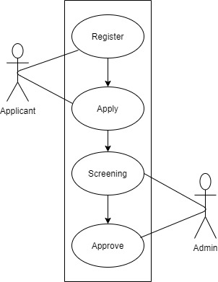

**Workflow / Process Flows (AS-IS)**

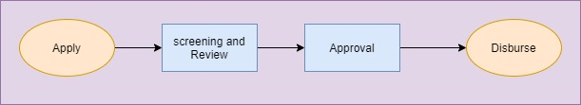

**Workflow / Process Flows (TO-BE)** 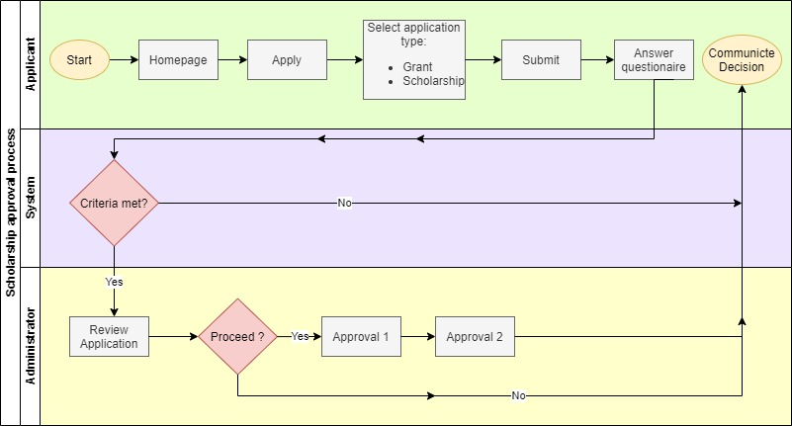

**Non-Functional Requirements**

|  |  |
| --- | --- |
| **Non-functional requirement category** | **Non-functional requirement** |
| Performance | The system shall have a response time of 0.1 seconds |
| System requirement | The feature will run on SQL server database and Microsoft.net |
| Scalability | The registration page shall support 500 hundred users per hour |
| Availability | The webpage must be available to Users 98% of the time every month |
| Reliability | The system must have 85 percent reliability for a month |
| Maintainability | The system must have 75 percent maintainability for 24 hours |
| Security | The system shall encrypt personal information |

**Functional Requirements**

|  |  |  |
| --- | --- | --- |
| **Requirement_ID** | **User_Story** | **Requirements** |
| 1 | As an applicant  I want to be able to access the Board’s Scholarship portal  So that I can navigate to apply for a scholarship or grant | * When I input <https://www.calgaryscholarshipboard.com> on my browser’s address bar, the system shall direct me to the homepage of Calvary Scholarship Board’s portal * The homepage shall display tabs containing selectable links to all the functionalities of the portal. The tabs shall include: * Home * Register * Apply * Track * Contact us * Follow Us * The Home menu shall remain at a fix position all through the portal’s functionalities and shall redirect users to the home page at any moment it is selected. * When the Register link is selected, the system shall redirect the user to the registration form containing form for applicant registration * When the Apply link is selected, the system shall redirect user to scholarships and grants application form * The Track link when selected shall redirect the user to the application tracker page where status of applicant’s application is displayed * When the Contact us link is selected, the system shall redirect user to the Board’s contact details containing email address, phone number and corporate office address * The system shall display selectable icons of the respective social media pages the Board is signed on to when the follow us button is selected. * The homepage shall have a background picture slideshow that display achievements and activities of the scholarship board * Copyright information and year shall be centrally displayed at base of homepage in smaller fonts |

Mockups

